|  |  |  |  |  |
| --- | --- | --- | --- | --- |
| Exp.No. | **01** | **Cloud Account Setup and Services Overview** | **Year/Sem** | II |
| Date | 08/03/25 | **Branch** | B.tech AI&ML |

# Aim:

To create an AWS cloud account and explore its various services.

# Procedure:

1. The steps to create a AWS cloud account:
   * **Visit the AWS Website**: Go to the AWS home page.
   * **Create an Account**: Click on "Create an AWS Account." If you don't see this option, you might need to sign out of any existing AWS accounts first.
   * **Enter Account Information**: Provide your email address and choose a strong password. Make sure your password meets AWS's security requirements.
   * **Verify Email**: AWS will send a verification code to your email. Enter this code to verify your email address.
   * **Add Contact Information**: Choose whether the account is for personal or business use and enter the required contact details.
   * **Add Payment Method**: Provide your payment information. AWS requires a valid credit card for account creation.
   * **Verify Phone Number**: AWS will call or text you to verify your phone number.
   * **Choose Support Plan**: Select a support plan that suits your needs. AWS offers several options, including a free tier.
   * **Complete Sign-Up**: Review your information and complete the sign-up process. You will receive a confirmation email once your account is ready to use
2. AWS Cloud Services Guide:

Amazon Web Services (AWS) is a comprehensive cloud computing platform provided by Amazon. It offers a wide range of services, such as computing power, storage, and databases, which enable businesses to scale and grow without the need for physical infrastructure. AWS provides solutions for various industries, including startups, enterprises, and government organizations.

* + **Compute**: Services like EC2 (Elastic Compute Cloud) allow you to run virtual servers in the cloud.
  + **Storage**: S3 (Simple Storage Service) provides scalable and secure storage for your data.
  + **Databases**: RDS (Relational Database Service) and DynamoDB offer managed database solutions

# AWS:

**Services in AWS:**

* Compute Services
  1. EC2 (Elastic Compute Cloud) provides resizable compute capacity in the cloud. You can launch virtual servers, manage security and networking, and scale resources based on demand.
  2. Lambda**:** Enables serverless computing by running code without provisioning or mana ging servers. Automatically scales based on demand.
* Storage Services
  1. S3 (Simple Storage Service)**:** Scalable object storage service with high durability and availability. Store and retrieve any amount of data from anywhere on the web.
  2. EBS (Elastic Block Store)**:** High-performance block storage for use with EC2 instances. Suitable for databases, file systems, and raw block-level storage.
* Database Services
  1. RDS (Relational Database Service)**:** Managed relational database service supporting multiple database engines. Easily set up, operate, and scale databases in the cloud.
  2. DynamoDB**:** Fully managed NoSQL database service with fast and predictable performance. Ideal for applications requiring single-digit millisecond latency.
* Networking and Content Delivery
  1. VPC (Virtual Private Cloud): Launch AWS resources into a virtual network you've defined. Provides isolated network environments similar to a traditional data center.
  2. Route 53: Scalable DNS and domain name registration service. Route user requests to infrastructure running in AWS or outside of AWS.
* Security, Identity, and Compliance
  1. IAM (Identity and Access Management): Securely control access to AWS services and resources for your users. Manage users and permissions for access control.
  2. KMS (Key Management Service): Managed service for creating and controlling encryption keys. Encrypt data across AWS workloads with ease.
* Machine Learning and AI
  1. SageMaker: Build, train, and deploy machine learning models quickly. Provides tools for every developer and data scientist to design and deploy ML models.
  2. Rekognition: Add image and video analysis to applications. Identify objects, people, text, and activities in images and videos.
* Analytics
  1. Athena: Interactive query service to analyze data in Amazon S3 using standard SQL. Serverless and pay-only-for-queries-run model.
  2. EMR (Elastic MapReduce): Managed Hadoop framework for processing vast amounts of data. Easily process data with tools like Hadoop and Spark.
* Developer Tools
  1. CodeCommit: Fully managed source control service for hosting secure and scalable Git repositories.
  2. CodeBuild: Continuous integration service for compiling source code, running tests, and producing ready-to-deploy software packages.
* IoT (Internet of Things)
  1. IoT Core: Connect IoT devices to the AWS cloud securely. Manage billions of devices and trillions of messages with reliable routing.
  2. IoT Greengrass: Extend AWS to edge devices for local data processing. Use cloud management, analytics, and storage.
* Management and Governance
  1. CloudWatch: Monitoring service for AWS resources and applications. Provides insights for optimizing resource utilization.
  2. CloudFormation: Manage AWS resources as code. Provision and update resources predictably and orderly.

# Applications of AWS:

1. Amazon EC2 (Elastic Compute Cloud):
   * Use Case: Hosting applications and websites, running big data analytics, and providing scalable computing capacity.
     + Example: Netflix uses EC2 to handle its streaming services and manage its vast content library.
2. Amazon S3 (Simple Storage Service):
   * Use Case: Storing and retrieving any amount of data, backup and restore, and data archiving.
   * Example: Dropbox uses S3 to store and manage user files
3. Amazon RDS (Relational Database Service):
   * Use Case: Managing relational databases with ease, automating administrative tasks like backups and patching.
   * Example: Airbnb uses RDS to manage its database of listings and user information.
4. Amazon DynamoDB:
   * Use Case: Providing fast and flexible NoSQL database services for applications that require consistent, single-digit millisecond latency.
   * Example: Lyft uses DynamoDB to store and retrieve ride data in real-time.
5. Amazon Lambda:
   * Use Case: Running code in response to events without provisioning or managing servers, ideal for microservices and serverless applications.
   * Example: Coca-Cola uses Lambda to process transactions from vending machines.
6. Amazon CloudFront:
   * Use Case: Delivering content with low latency and high transfer speeds, ideal for websites, APIs, and video streaming.
   * Example: Amazon Prime Video uses CloudFront to deliver streaming content to users worldwide.
7. Amazon Redshift:
   * Use Case: Analyzing large datasets quickly and cost-effectively, ideal for data warehousing and business intelligence.
   * Example: Yelp uses Redshift to analyze user reviews and business data.
8. Amazon SageMaker:
   * Use Case: Building, training, and deploying machine learning models at scale.
   * Example: Intuit uses SageMaker to develop and deploy machine learning models for fraud detection.
9. Amazon Elastic Beanstalk:
   * Use Case: Deploying and managing applications in various languages without worrying about the underlying infrastructure.
   * Example: The Washington Post uses Elastic Beanstalk to manage its content delivery platform.
10. Amazon Kinesis:
    * Use Case: Real-time data streaming and analytics, ideal for processing and analyzing large streams of data.
    * Example: Zillow uses Kinesis to process and analyze real-time user interactions on its platform.

# Output:

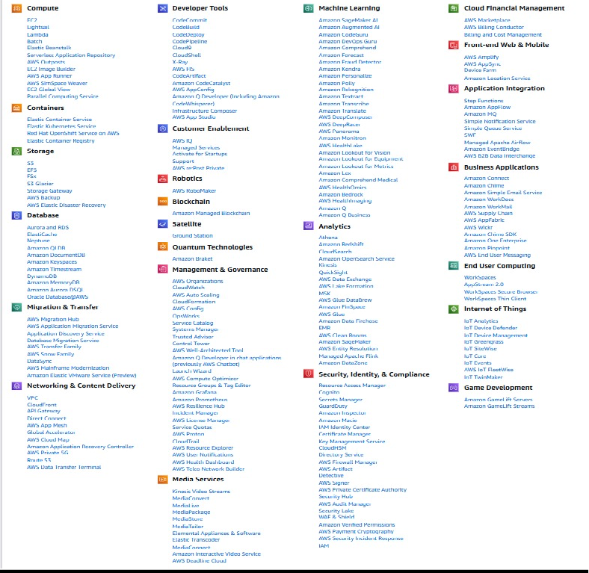

**Conclusion:**

AWS provides a broad range of cloud services tailored to meet various business needs. By leveraging AWS, businesses can achieve scalable computing, secure storage, and advanced data analytics. These tools help companies innovate, reduce costs, and improve performance. Whether a startup or a large enterprise, AWS offers the flexibility and efficiency required to stay competitive. AWS cloud services empower businesses to succeed in today's digital world.

# Result:

The experiment demonstrates that AWS offers a comprehensive and scalable cloud computing platform. The services are user-friendly, secure, and can meet diverse computing needs, from hosting applications to managing databases and storage.